Certificate of Analysis

General properties:
Name：mPEG5000-PLGA10000
Molecular Weight： PEG MW:5000, PLGA MW:10000
Cat.#： R-D-0221
Lot.#： 199512
Manufacture Date： 2015.10.26
Date of Analysis： 2015.10.26
Recommended Retest date： 2016.10.26
Stability： 12 months
Storage： -20°C in the dark

Structure

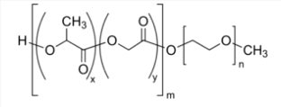

Items | Specification | Results
Appearance | Light yellow crystal | Light yellow crystal
¹H NMR | Identical to the structure | Identical to the structure
Foreign Material | None | None
Report Date: 2015.10.26

This product is for research use only, Not for human or animal use

